**DATA TRIBE CHALLENGE**

**PROJECT SUMMARY: AGRICULTURAL EXPORTS DASHBOARD**

**INTRODUCTION**

Agricultural exports are vital to Nigeria's economy, contributing to foreign exchange, employment, and industrial growth. However, the export sector is fraught with challenges such as fluctuating global demand, inefficiencies in supply chains, and limited insight into product-specific performance. These factors can erode profitability and reduce competitiveness in international markets. Tracking Key Performance Indicators (KPIs) such as export value, profit margins, and units sold is essential for identifying trends, evaluating the performance of products and companies, and uncovering growth opportunities. Effective monitoring and analysis of these KPIs enable businesses and policymakers to make informed decisions to optimize export operations and maximize profitability.

This project bridges the gap by creating an interactive agricultural export dashboard that consolidates data, providing a high-level view of key metrics, enabling stakeholders to monitor performance across products, companies, and countries. With focus on actionable insights, the dashboard supports better decision-making to optimize exports and enhance profitability.

**METHODOLOGY**

**Data Overview**

The data provided for this project included four (4) core datasets:

1. **Exports Basic** – This table contained key identifiers and high-level details such as Export ID, Product ID, Company ID, Date, and Export Countries.
2. **Exports Detailed** – This dataset provided granular information about each export transaction, including export value, units sold, unit price, profit per unit, destination port, and mode of transportation.
3. **Company** – Contained the Names and IDs of the exporting companies.
4. **Product** – Contained the Names and IDs of the products being exported.

To enhance the analytical capabilities of the project, two (2) additional dimension tables were created. These were a Date Table and Country Table.

**Date Table**

A date table was created to facilitate comprehensive time-series analysis across multiple hierarchies. Spanning the time frame of the data provided for this project, from 2020 to 2023, the date table included fields such as year, quarter, month name, day, week of the year, etc. These fields enable robust trend analysis, offering valuable insights for this project and future analyses. Additionally, the creation of the date table aligned with the best practices of the star schema methodology used in designing the dimensional data model for this project.

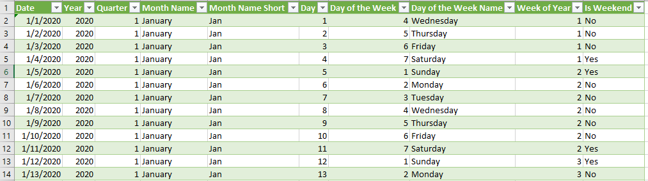***Overview of Date Table***

**Country Table**

The country dimension was created to effectively capture market data for export destination countries. For this project, the country table included only the names and IDs of export countries, it can however, be expanded to encompass additional information such as continent, region, GDP, and other valuable data as needed. To create the country dataset, the Exports Basic Table was loaded into the Power Query Editor. The relevant column (country name) was selected, duplicates were removed, and an index column was added to serve as unique country IDs.

**DATA CLEANING AND PREPARATION**

Preparing the data for analysis involved comprehensive cleaning, which was performed using the Power Query Editor. This process included loading all datasets into the editor and applying targeted cleaning steps to ensure each dataset was ready for analysis.

* **Exports detailed:** Cleaning this dataset required standardizing the currency columns (Unit Price, Profit per Unit, and Export Value) to a uniform currency format. Irregular currency symbols were addressed, as some entries were in dollars ($) while others were in Naira (#), resulting in an inconsistent format. These and other discrepancies were resolved to ensure uniformity. Additionally, misspellings in the Destination Port column (e.g., ‘Calabar’ spelt as ‘Cabalar’, ‘Lagos’ spelt as ‘Lagoss’, and Port Harcourt spelt as ‘Pot Harcourt’) were corrected. Hidden characters causing unnecessary duplication of port names were also removed using Replace Values, Trim, and clean in the Power Query.
* **Products and Companies Tables**: The major cleaning activities carried out here was to use the first row of both datasets as header, ensuring appropriate naming of the data fields.

**FEATURE ENGINEERING**

To ensure that the appropriate insights were uncovered, new columns were created in the exports detailed table. The created columns were:

* **Total Profit:** calculated as (profit per unit * units sold)
* **Profit Margin:** calculated as ((total profit / export value) *100)

**DATA MODELING**

The data modeling phase was a critical component of this project, ensuring seamless connections between tables for efficient data slicing and dicing. The model follows the Star Schema structure, with a central fact table linked to multiple dimension tables, enabling streamlined analysis. This model was developed using Power Pivot, ensuring robust and scalable data relationships.

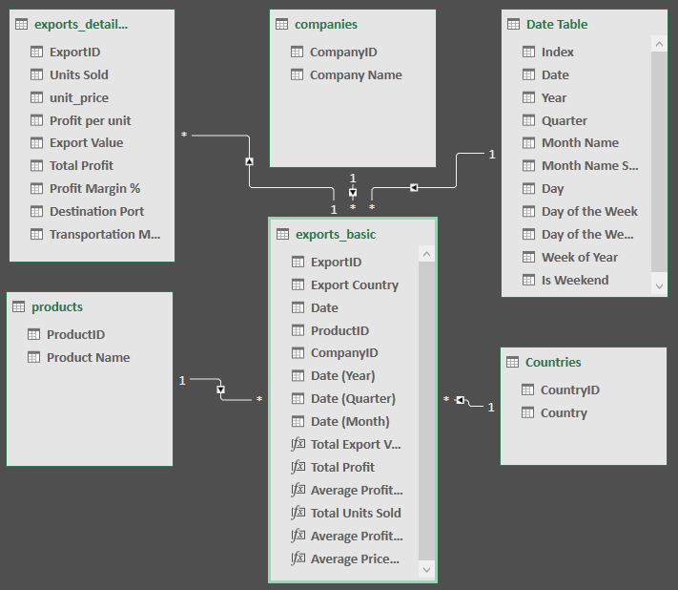

***The data model***

**Model Design**

**Fact Table:**

* **Exports Basic Table:** Served as the central table of the model, referencing dimension tables via their IDs and containing key export metrics for analysis.

**Dimension Tables:**

1. **Exports Detailed Table:** Held granular export data and linked to the fact table via the Exports ID column.
2. **Company Table:** Contained details of export companies and connected to the fact table through the Company ID column.
3. **Products Table:** Included information about exported products and linked to the fact table via the Product ID column.
4. **Date Table:** Provided time-related attributes to support time-based analysis and was connected to the fact table on the Date column.
5. **Country Table:** Contained details of destination countries and linked to the fact table using the Country Name column.

This star schema design facilitated efficient data organization and ensured seamless querying and analysis.

**MEASURES CREATION**

Measures were created to enable efficient data aggregation and dynamic calculations that seamlessly respond to slicers and filters. These measures provided customized metrics and ensured consistency in calculations across the analysis and visuals. After modeling, the following measures were developed within the Exports Basic (fact) table.

* Total Export Value
* Total Profit
* Average Profit Margin
* Total Units Sold
* Average Profit per Unit
* Average Price per Unit

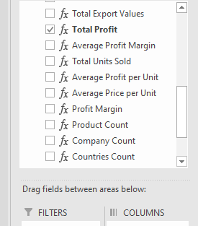

***Measures***

**DATA SUMMARIZATION**

To facilitate insightful analysis and meaningful visualizations, data summarization was performed using pivot tables. These were instrumental in aggregating large volumes of data into easily interpretable summaries. Key actions included:

1. **KPI Calculation:** Metrics such as total export value, total profit, units sold, profit margins, and average price per unit were computed based on the created measures and helped track performance indicators.
2. **Entity-Specific Summaries:** Data was grouped and summarized by key entities such as products, companies, and countries. For example, export value and total profit by product and company were highlighted to identify top-performing entities.
3. **Time-Series Analysis:** Using the Date data in the Exports basic table, backed by the Date Table, trends were analyzed over time by summarizing data at various hierarchies, including yearly, quarterly, and monthly levels. This allowed for tracking growth and seasonality patterns.
4. **Slicer Integration:** Summaries were enhanced with slicers, enabling dynamic filtering by products, companies, countries, and time periods. This ensured flexibility in analysis and the ability to focus on specific areas of interest.
5. **Alignment with Star Schema:** The data summarization process utilized the star schema structure, where relationships between the fact table and dimension tables ensured seamless aggregation and accurate computation.

The pivot tables formed the backbone of the dashboard, providing the necessary data structure to power visualizations and highlight actionable insights for stakeholders.

**DASHBOARD DESIGN**

The dashboard for this project was designed to provide clear, interactive insights into the agricultural export data, helping stakeholders track KPIs and make informed decisions. The design focuses on visualizing data across five core pages: Overview, Products, Companies, Countries, and Trends. Each page serves a distinct purpose, allowing users to explore the data from different perspectives. The layout is visually cohesive, with KPIs and charts that are easy to read and interact with.

**1. Overview Page:**

The Overview Page provides high-level insights into the overall export operations. This page serves as the entry point for understanding the performance of the entire export business. It focuses on the following key metrics:

* Total Export Value
* Total Profit
* Total Units Sold
* Number of Products, Companies and Countries
* Most Profitable Product
* Most Profitable Company
* Most Profitable Country
* Top Destination Port
* Top 5 products by export value
* Top 5 companies by export value
* Ports Ranking by Export Volume

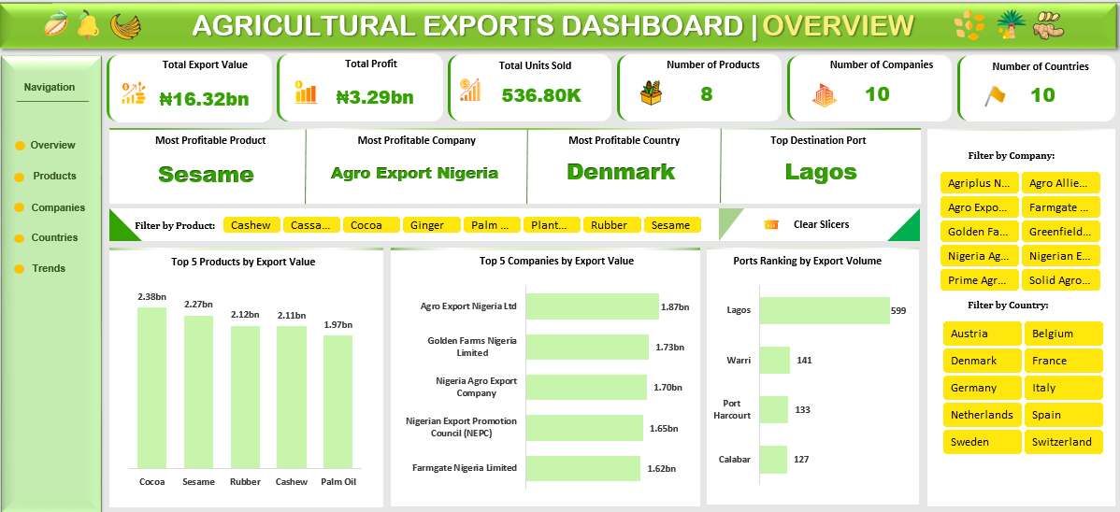

**2. Products Page:**

The Products Page is dedicated to exploring the products being exported and their financial performance. It provides a detailed breakdown of export value, profit, and profitability by product.

KPIs Displayed:

* Total Export Value by Product
* Total Profit by Product
* Profit Margin
* Most Profitable Product

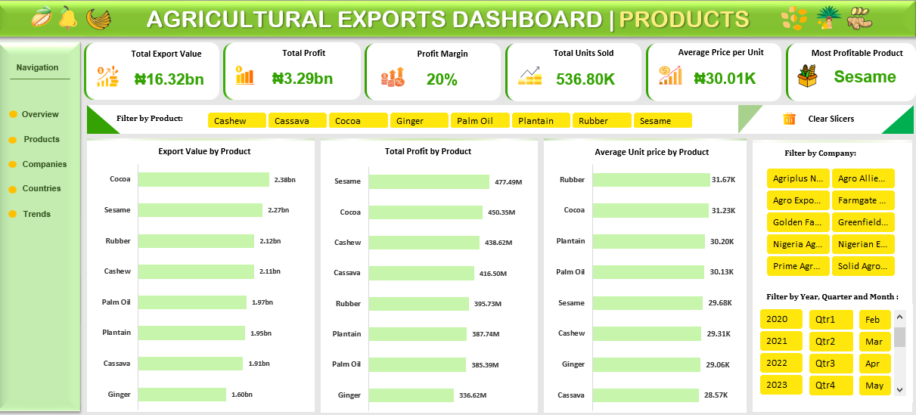

**3. Companies Page:**

The Companies Page provides insights into the performance of export companies, showing their contributions to the total export value and profitability.

KPIs Displayed:

* Total Export Value by Company
* Total Profit by Company
* Profit Margin by Company
* Most Profitable Company

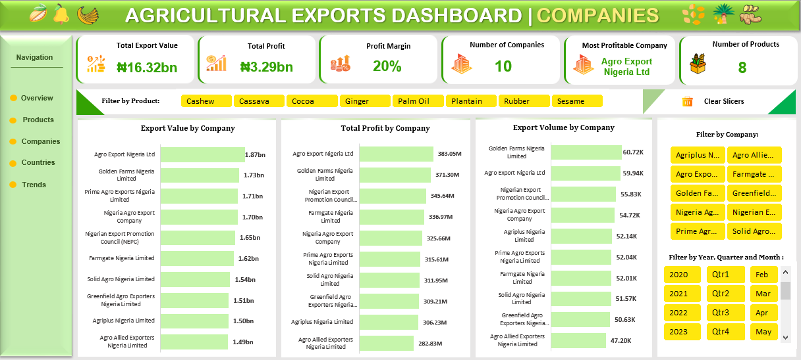

**4. Country Page:**

The Countries Page is focused on the destination countries, providing insights into where the products are being exported and the profitability of these markets.

KPIs Displayed:

* Total Export Value by Country
* Total Profit by Country
* Profit Margin by Country
* Most Profitable Country

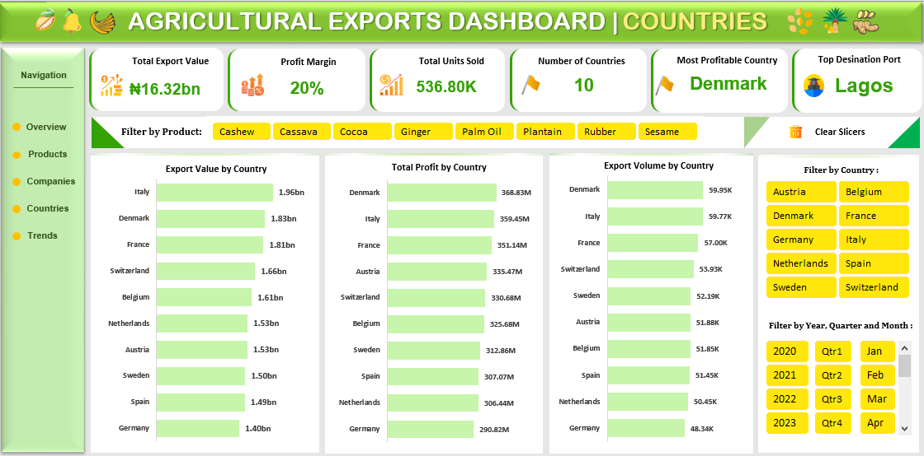

**5. Trends Page:**

The Trends Page focuses on time-series analysis, tracking the performance of exports over different time periods. This page helps identify trends, seasonal patterns, and growth over time.

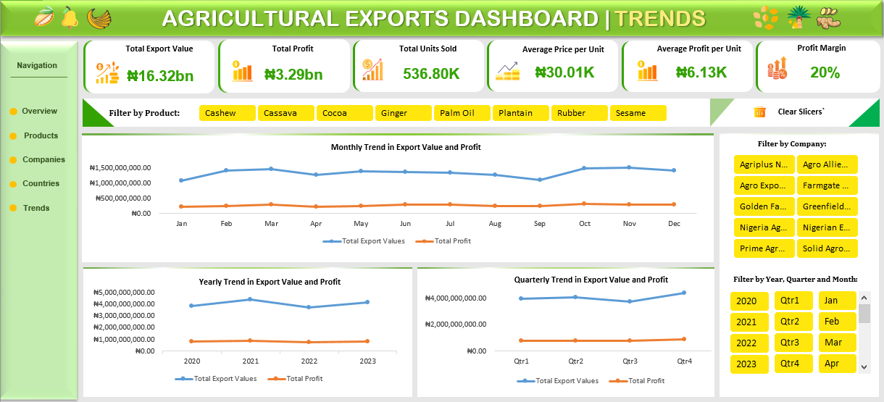

**Design Considerations:**

The dashboard was designed with the following key principles to ensure a user-friendly and interactive experience:

* **Interactivity:** Slicers were incorporated throughout the dashboard, allowing users to slice and dice the data by time, company, product, and country, providing flexibility in data exploration.
* **Color Scheme**: A consistent use of green and yellow was maintained across the dashboard to ensure visual coherence and ease of navigation.
* **Data Alignment:** All charts, tables, and KPIs were carefully aligned and spaced for optimal readability and aesthetic appeal. The use of clear, distinct visuals ensures that key metrics are easily identifiable.

The dashboard was designed to present a comprehensive, yet easily understandable, view of the agricultural export data, offering a clear overview of performance across products, companies, countries, and time periods

**SPECIAL FEATURES**

* **Macro-Enabled Slicer Clearing:** Powered by a recorded macro, this feature efficiently clears active slicers, replacing the default slicer clearing functionality. This enhancement streamlines data exploration while contributing to the dashboard's polished appearance.
* **Entity Highlighting:** This is a standout feature that highlights selected entities (Products, Companies, or Countries) across the dashboard. This ensures quick identification and tracking of insights, enhancing data comprehension.

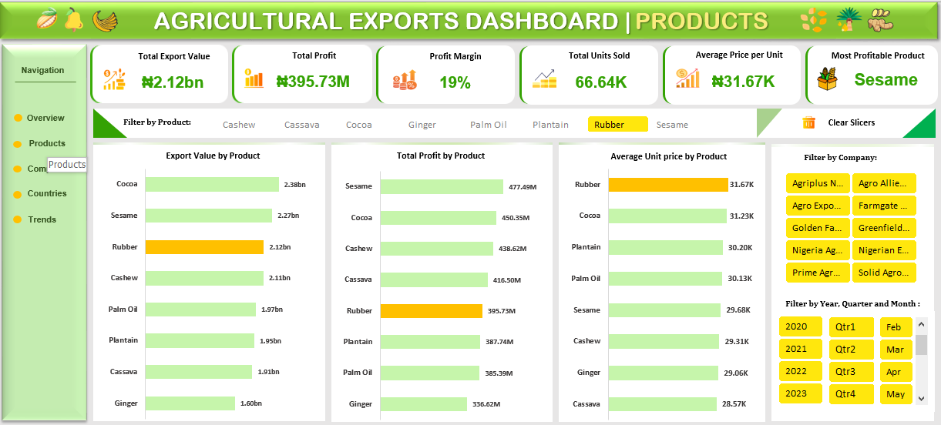

* **Seamless Navigation:** The dashboard incorporates a hyperlink-based page navigation system, enabling effortless movement between pages. This design ensures a smooth user experience, promoting efficiency and ease of use.

**ANALYSIS INSIGHTS**

The analysis of the agricultural export data revealed the following key insights:

**1. Overall Metrics:**

* **Total Export Value:** ₦16,317,664,478.57.
* **Total Profit:** ₦3,288,449,155.39.
* **Total Units Sold:** 536,804.
* **Profit Margin:** 20%.
* **Number of Products:** 8.
* **Number of Companies:** 10.
* **Number of Countries:** 10.

**2. Performance Highlights:**

* **Most Profitable Product**: Sesame.
* **Most Profitable Company**: Agro Exports Nigeria Limited.
* **Most Profitable Country:** Denmark.
* **Top Destination Port:** Lagos.

**3. Product-Based Insights:**

* **Top Product by Export Value:** Cocoa.
* **Top Product by Profit:** Sesame.
* **Most Expensive Product (by Average Unit Price):** Rubber.

**4. Company-Based Insights:**

* **Top Company by Export Value and Profit:** Agro Exports Nigeria Limited.
* **Top Company by Export Volume:** Golden Farms Nigeria Limited.

For this project summary, the key insights have been highlighted. However, the interactive dashboard provides a wealth of deeper, entity-specific insights, offering users the flexibility to explore and analyze the data in greater detail.

**CONCLUSION**

This project successfully utilized data cleaning, modeling, and visualization techniques to transform raw agricultural export data into actionable insights. The interactive dashboard, underpinned by a robust star-schema data model, provides a comprehensive view of export performance. By focusing on critical KPIs and enabling deeper exploration, the project highlights current trends and profitability drivers, equipping stakeholders with the tools needed for strategic decision-making and long-term growth in the agricultural export sector. Furthermore, this project addresses the need for enhanced visibility into the sector's performance, promoting data-driven decision-making and enabling the strategic optimization of export activities. Ultimately, the dashboard contributes to improved profitability, operational efficiency, and competitive positioning in global markets.